**Task1:**

**Main:**

package application;

import javafx.application.Application;

import javafx.fxml.FXMLLoader;

import javafx.stage.Stage;

import javafx.scene.Parent;

import javafx.scene.Scene;

public class Main extends Application {

@Override

public void start(Stage stage) {

try {

Parent root = FXMLLoader.load(getClass().getResource("newfxmnl.fxml"));

Scene scene = new Scene(root);

stage.setScene(scene);

stage.show();

} catch(Exception e) {

e.printStackTrace();

}

}

public static void main(String[] args) {

launch(args);

}

}

**Secondcontroller:**

package application;

import java.io.IOException;

import javafx.event.ActionEvent;

import javafx.fxml.FXMLLoader;

import javafx.scene.Node;

import javafx.scene.Parent;

import javafx.scene.Scene;

import javafx.stage.Stage;

public class secondcontroller {

public void switchToScene2(ActionEvent event) throws IOException {

Stage stage = new Stage();

Parent root = FXMLLoader.load(getClass().getResource("second.fxml"));

Scene scene = new Scene(root);

stage.setScene(scene);

stage.show();

}

public void switchToScene1(ActionEvent event) throws IOException {

Stage stage = new Stage();

Parent root = FXMLLoader.load(getClass().getResource("newfxmnl.fxml"));

Scene scene = new Scene(root);

stage.setScene(scene);

stage.show();

}

}

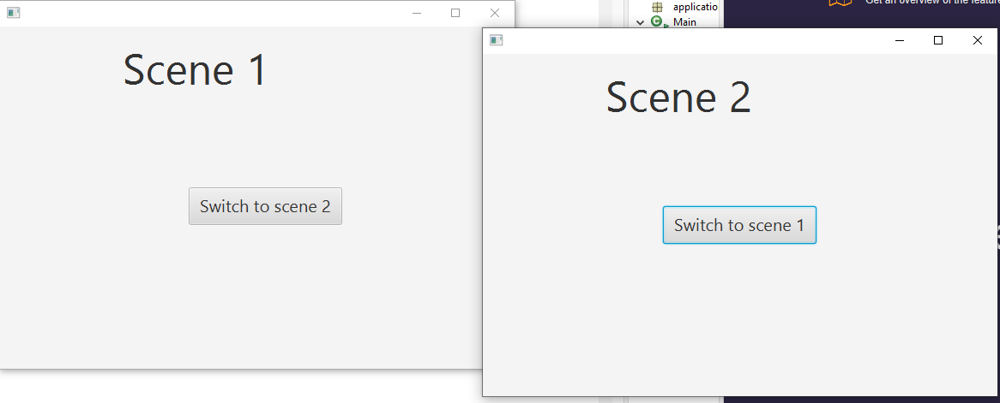

**Task2:**

**Main:**

package application;

import javafx.application.Application;

import javafx.fxml.FXMLLoader;

import javafx.stage.Stage;

import javafx.scene.Parent;

import javafx.scene.Scene;

public class Main extends Application {

@Override

public void start(Stage stage) {

try {

Parent root = FXMLLoader.load(getClass().getResource("Login.fxml"));

Scene scene = new Scene(root);

stage.setScene(scene);

stage.show();

} catch(Exception e) {

e.printStackTrace();

}

}

public static void main(String[] args) {

launch(args);

}

}

**Scenecontroller:**

package application;

import java.io.IOException;

import javafx.application.Application;

import javafx.event.ActionEvent;

import javafx.fxml.FXMLLoader;

import javafx.stage.Stage;

import javafx.scene.Scene;

import javafx.scene.*;

import javafx.scene.Parent;

import javafx.scene.layout.BorderPane;

import javafx.scene.Node;

public class SceneController {

Stage stage = new Stage();

public void LoginWindow(ActionEvent event) throws IOException {

Parent root = FXMLLoader.load(getClass().getResource("Login.fxml"));

Scene scene = new Scene(root);

stage.setScene(scene);

stage.show();

}

public void RegisterWindow(ActionEvent event) throws IOException {

Parent root = FXMLLoader.load(getClass().getResource("Register.fxml"));

Scene scene = new Scene(root);

stage.setScene(scene);

stage.show();

}

public void Logout(ActionEvent event) throws IOException {

Parent root = FXMLLoader.load(getClass().getResource("Logout.fxml"));

Scene scene = new Scene(root);

stage.setScene(scene);

stage.show();

}

}





